Kubernetes Assignments
- Deploy a Simple Web Application on Kubernetes
  - Install a Kubernetes cluster using kubeadm or minikube.
  - Deploy a backend and Frontend application
  - Expose the pod using a Service (kubectl expose pod nginx --port=80 --type=NodePort).
  - Submit the output of kubectl get pods and kubectl get svc.
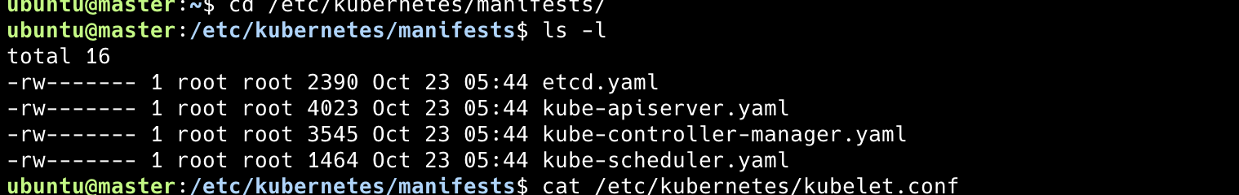
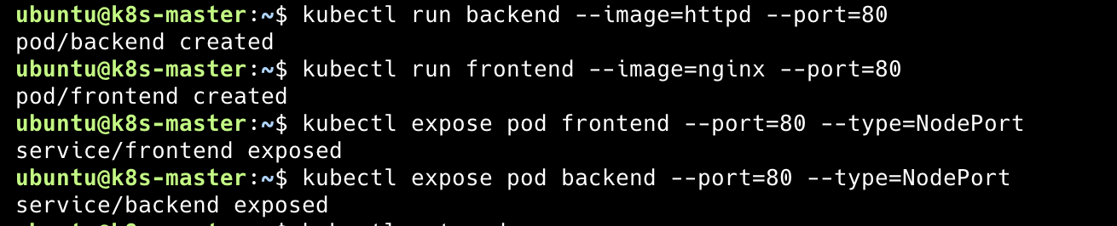
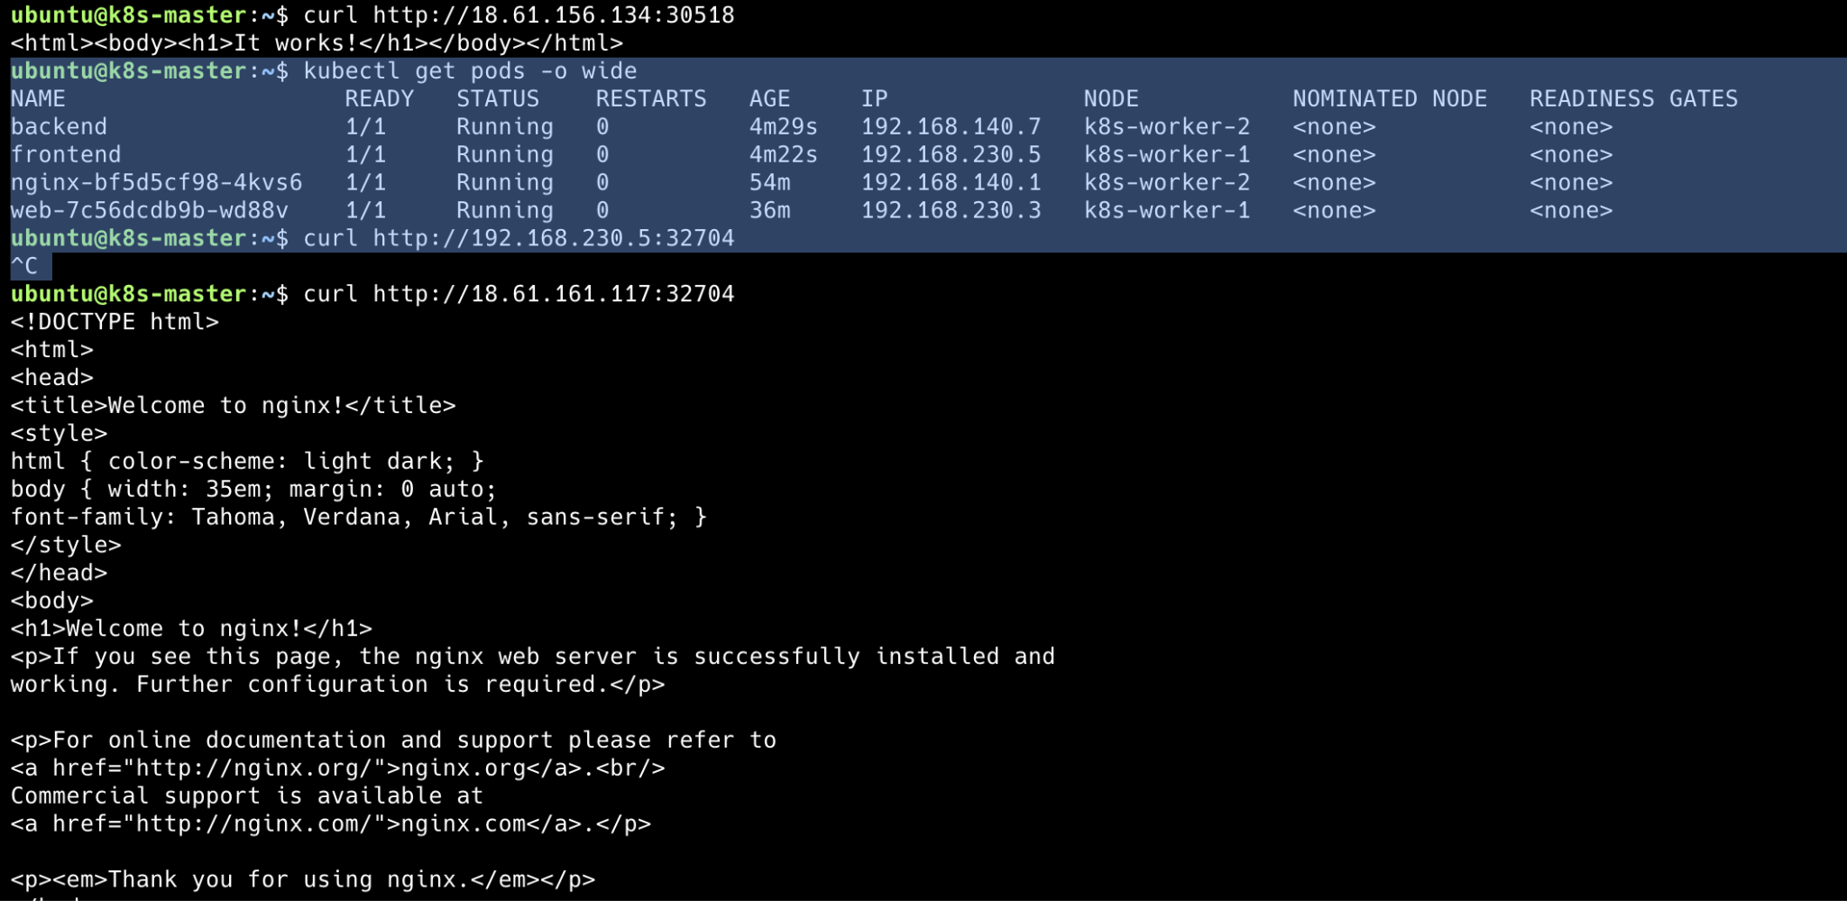
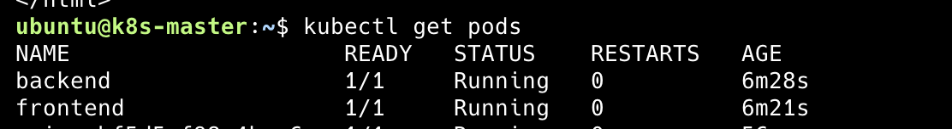
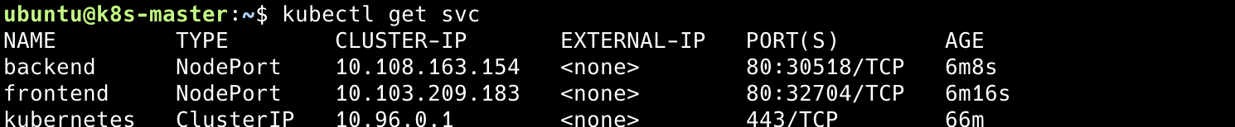

- Deploy an Application Using a Deployment
  - Create a Deployment for a simple web app (use nginx).
  - Scale the deployment to 3 replicas using kubectl scale.
  - Expose the application using a NodePort service.
  - Submit YAML files for Deployment and Service.

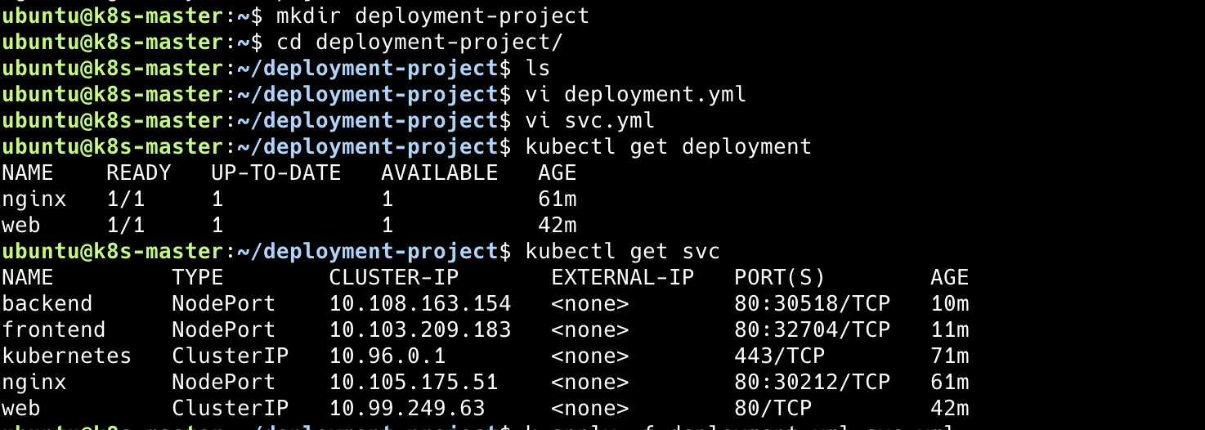
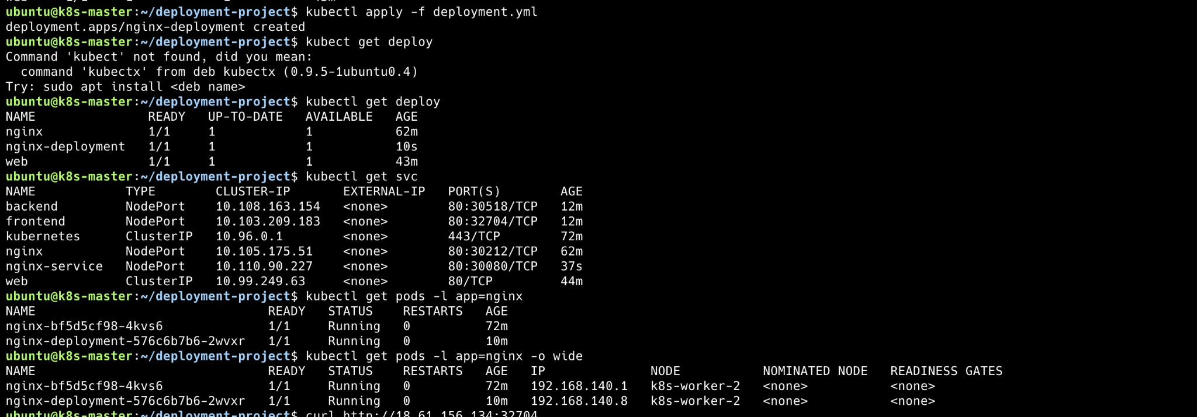
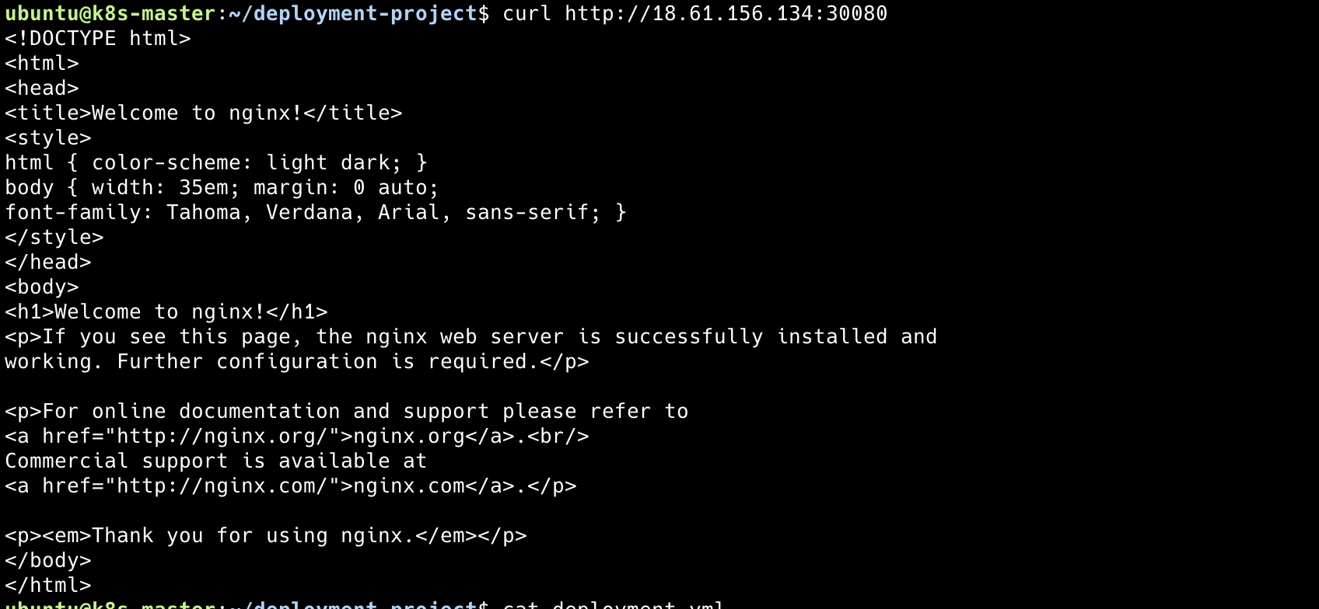
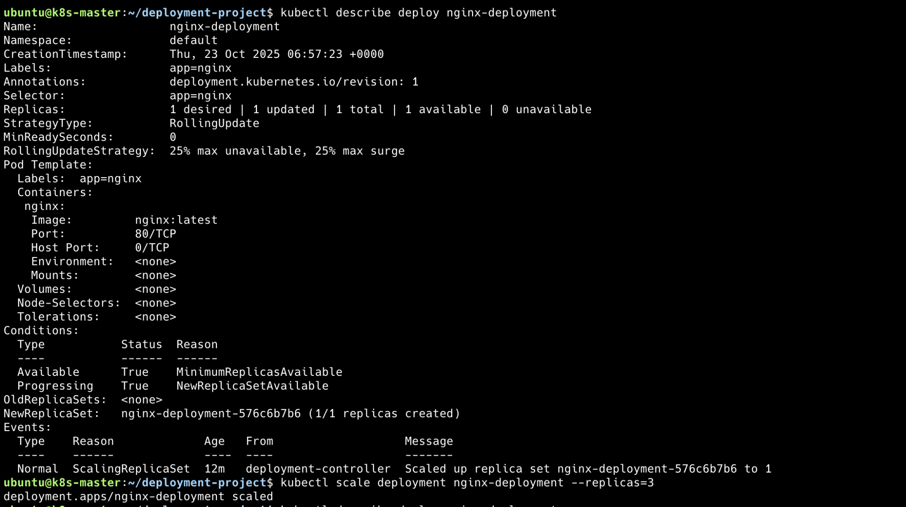

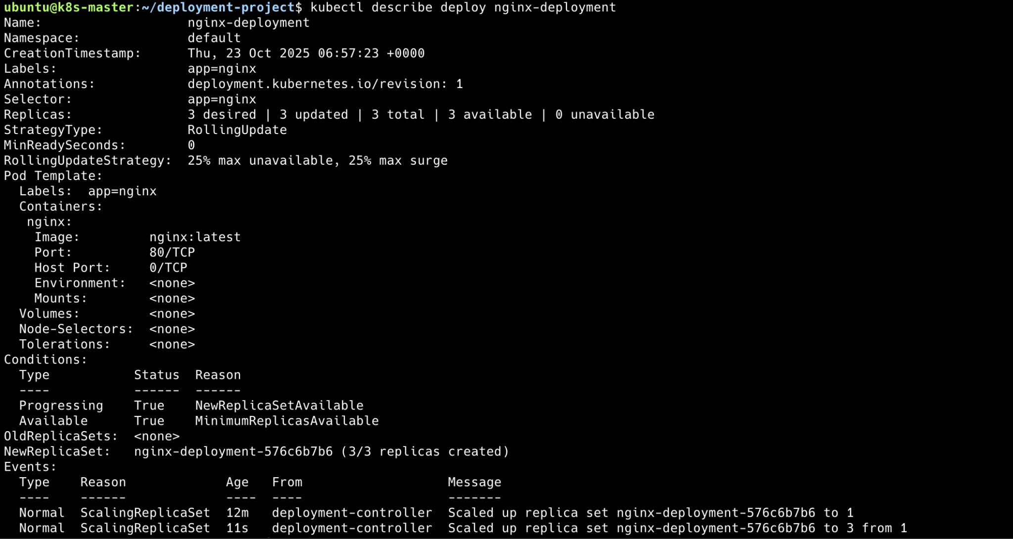
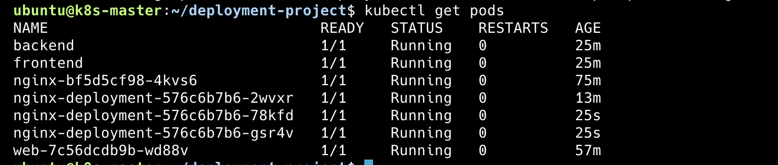

- Deploy a Multi-Container Application using Kubernetes
  - Deploy a frontend (React/Angular) and backend (Node.js/Python) using Deployments.
  - Expose the backend as a ClusterIP service.
  - Expose the frontend as a NodePort service.
  - Submit YAML files and service verification using kubectl get all.
